Bank Configuration Portal User’s Manual

Summary

The Bank Configuration Portal is a collaborative application that gives bank administrators full flexibility and control over their bank’s configuration, with complete support for both Arabic and English interfaces. It provides a seamless way to manage branches and services, allowing administrators to add, edit, and delete both as needed.
The portal also enables administrators to manage counters within each branch and configure the services assigned to each counter. These allocations determine which of the bank’s predefined services each counter can provide to customers, making branch and service management simple, organized, and efficient.

Opening the App (Login page)

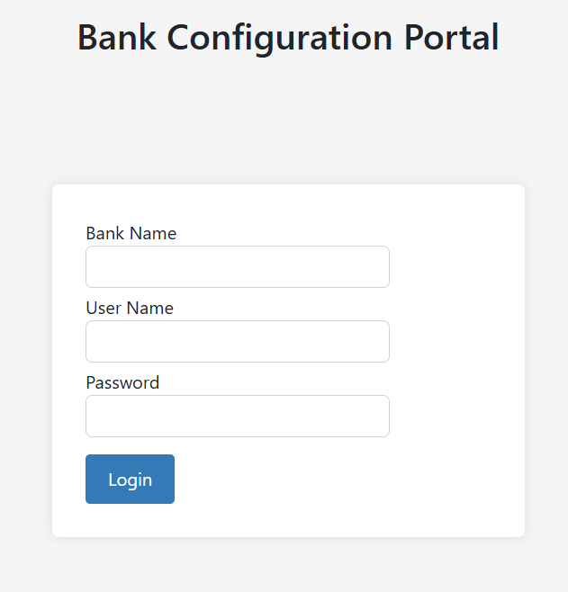
- Enter: http://localhost:”Replace this with your port number” in Browser’s URL

- Fill the login Form with your admin Information: bank name, user name and password and press Login button. Note: all of this information is case sensitive.

Admin Dashboard page

- This page contains two buttons to navigate the user either to managing branches or services.

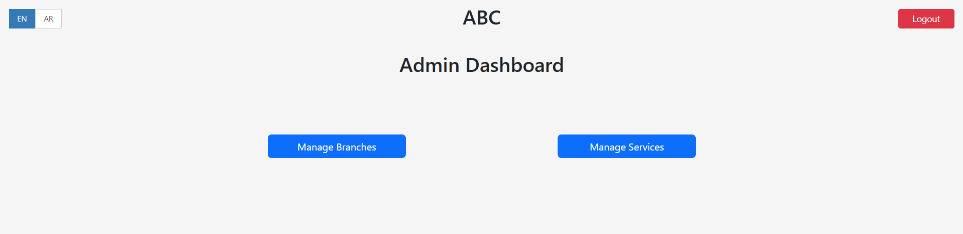

Service Management Page

- Admin can Add, Edit or delete a service in Service Management page, the table displays 10 services per page. Use the Next, Previous, or page number buttons to navigate.
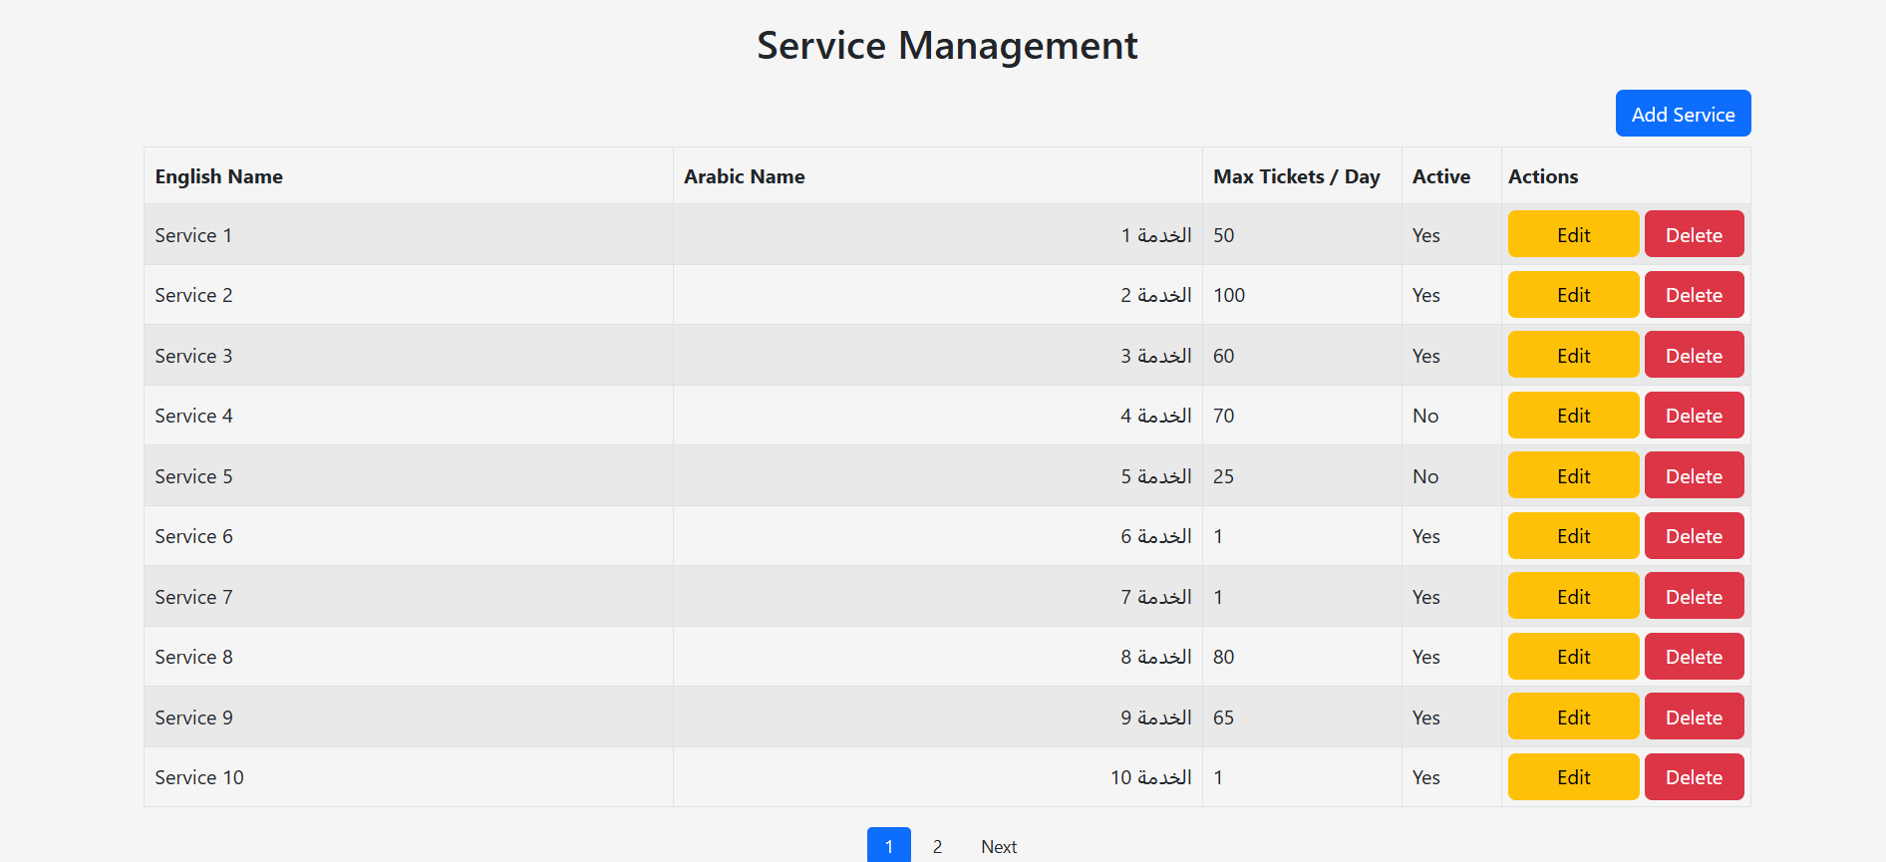

- Pressing Delete will ask a confirmation before going through with the action.

- Pressing Add Service will navigate the user to service create page.
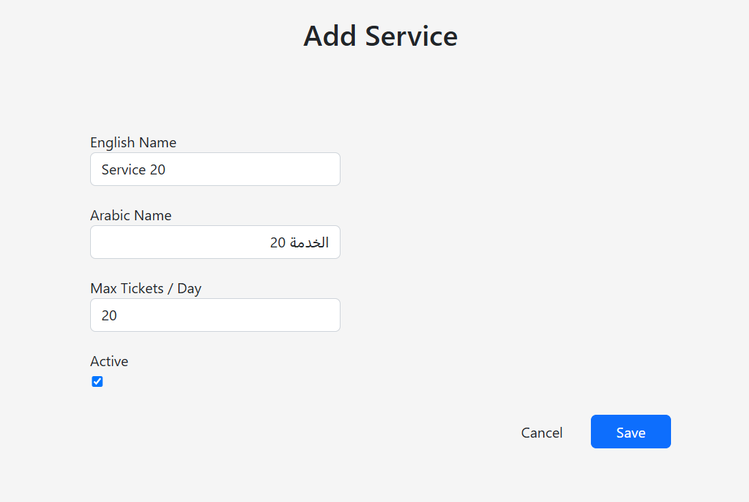

- English name can’t be filled with Arabic letters and vice versa for the Arabic name.

- Max ticker per day must be filled with a number between 1 and 100.

- You can set the active status of the service through checking the checkbox.

- All these Boxes must be filled in the form in order for the save to take place.

- Editing the service opens the same form but with current service Information.

Branch Management Page

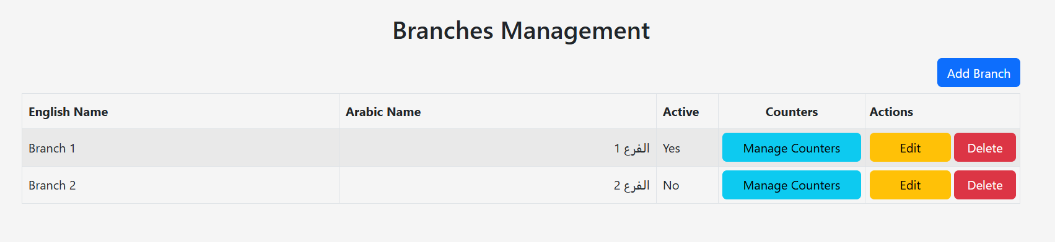
- Admin can Add, Edit or delete a branch in Branch Management page, the table displays 10 Branches per page. Use the Next, Previous, or page number buttons to navigate.

- Pressing Delete will ask a confirmation before going through with the action.

- Pressing Add Branch will navigate the user to Branch create page.
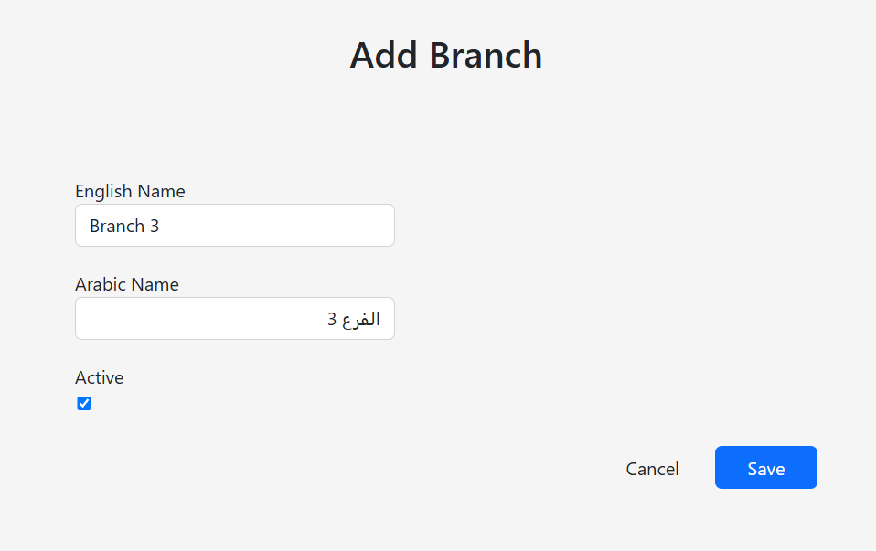

- English name can’t be filled with Arabic letters and vice versa for the Arabic name.

- You can set the active status of the branch through checking the checkbox.

- All these Boxes must be filled in the form in order for the save to take place.

- Editing the branch opens the same form but with current branch Information.

- Press Manage counters on the branch, the admin wants to manage its counters.

Counters Management Page

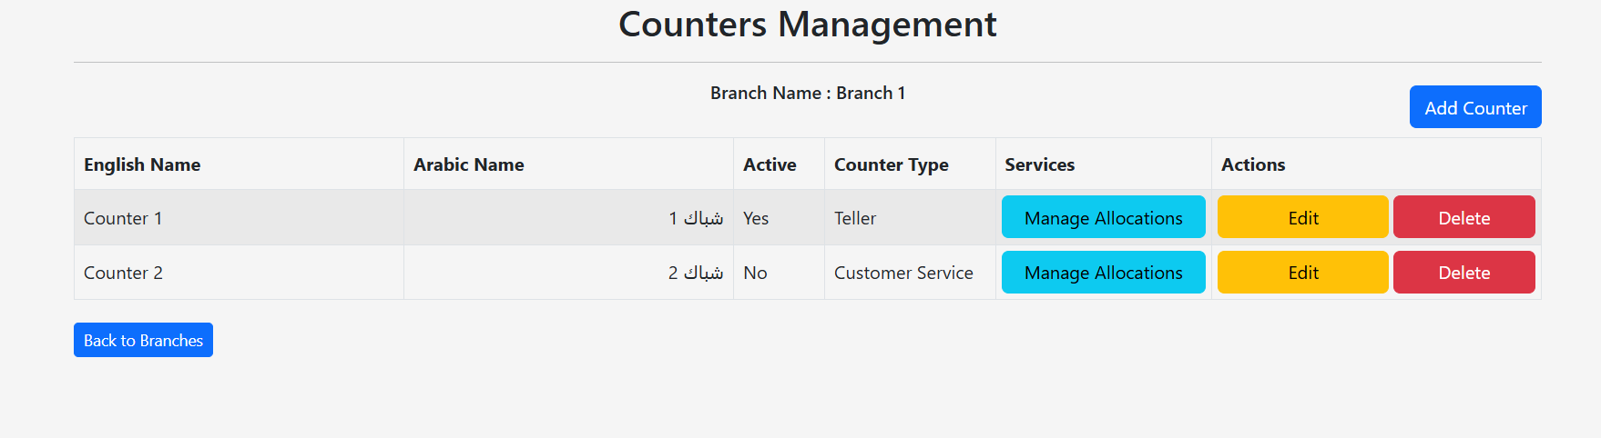
- Admin can Add, Edit or delete a counter in Counter Management page, the table displays 10 counters per page. Use the Next, Previous, or page number buttons to navigate.
- Pressing Delete will ask a confirmation before going through with the action.

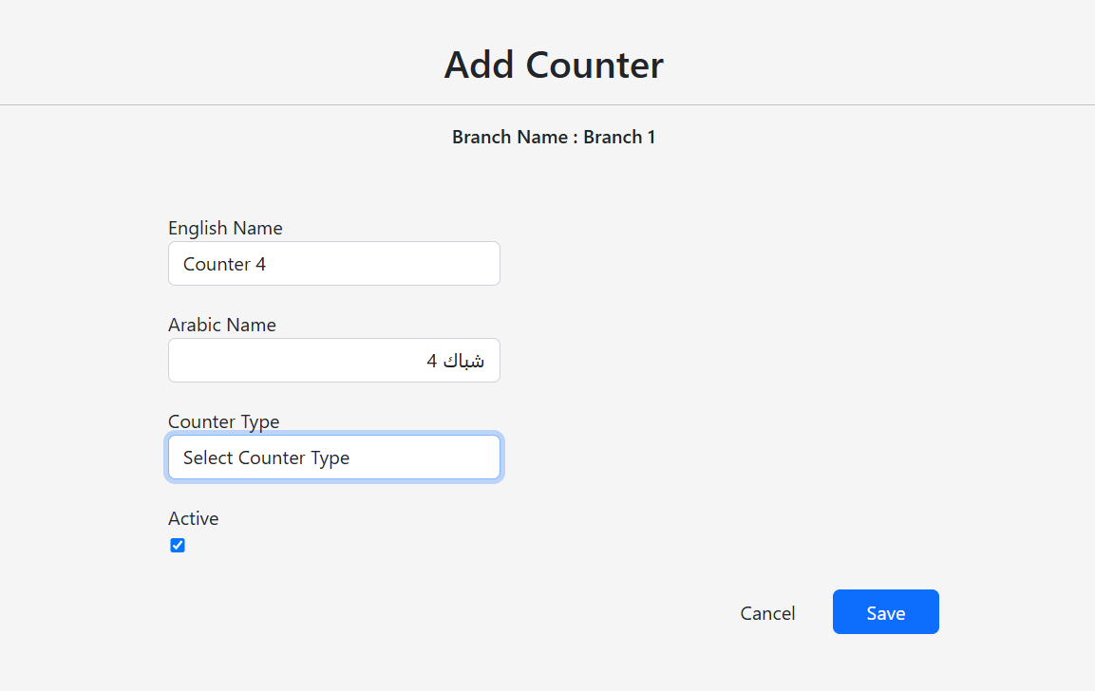
- Pressing Add Counter will navigate the user to Counter create page.

- English name can’t be filled with Arabic letters and vice versa for the Arabic name.

- You can set the active status of the counter through checking the checkbox.

- User must set Counter type in the dropdown list so Create/Edit can be saved.

- All these Boxes must be filled in the form in order for the save to take place.

- Editing the counter opens the same form but with current counter Information.

- Press Manage Allocations on the Counter, the admin wants to manage its Service Allocations.

Service Allocations Management Page

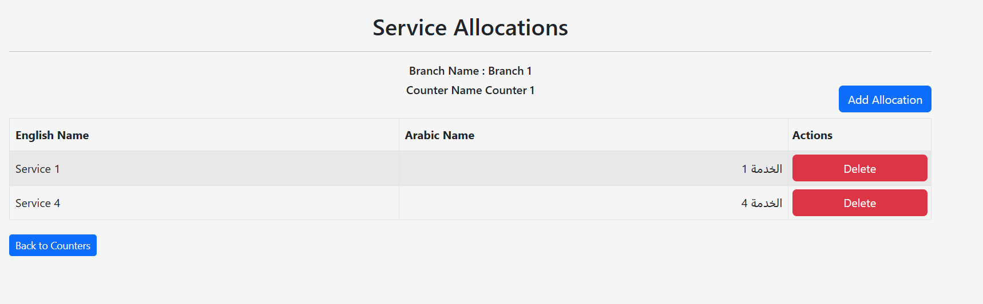
- Admin can assign or delete a service allocation in service allocation Management page, the table displays 10 service allocations per page. Use the Next, Previous, or page number buttons to navigate.

- Pressing Delete will ask a confirmation before going through with the action.

- Pressing Add Counter will navigate the user to Add allocation page.
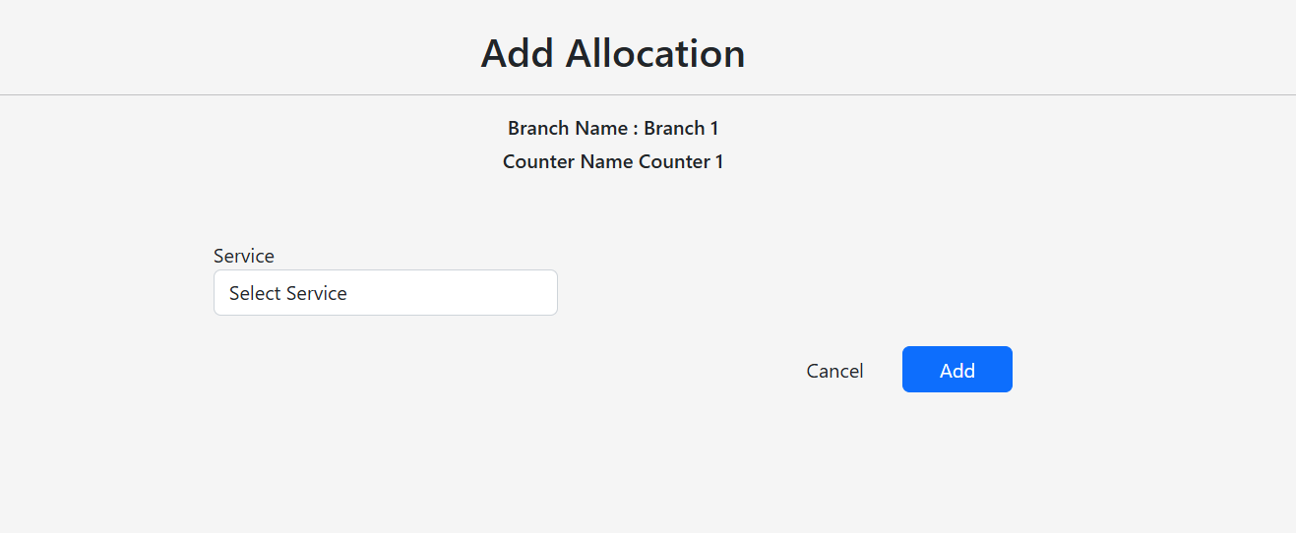

- User must set a service before pressing save.

Notes

- Always Read pop-ups and Messages in order to either know what is wrong or report an issue.

- All of English/Arabic names of Services, Branches and Counters can’t exceed 100 characters.

- You can always Logout from any page in the Application.

- You can always switch into English/Arabic language in any page (mind: if you are filling information in a form you will lose the current filled data).

- You can always navigate back to Dashboard in any page.

- Use the in-app navigation buttons to browse pages. Relying on the browser's Back button may cause navigation inconsistencies.

